**PART 1**

/*

--1

SELECT count(*) as "Number of employees"

FROM employee

*/

/*

--2

SELECT count(*) as "Number of J.S"

FROM employee

WHERE Fname LIKE "J%" and Lname LIKE "S%"

*/

/*

--3

SELECT Sex , count(*) as "Total"

FROM employee

GROUP by Sex

*/

/*

--4

SELECT Pname, max(Dnum) as "max employees"

FROM project

*/

/*

--5

WITH var as (

SELECT Essn,count(*) as c

FROM dependent d

WHERE d.Relationship not like "spouse"

GROUP by d.Essn)

SELECT e.Fname

FROM var v,employee e

WHERE v.Essn = e.Ssn AND c > 1

*/

/*

/*

--6+7

WITH var as (

SELECT e.Dno,count(*) employees

FROM employee e

GROUP by e.Dno

)

SELECT d.Dname,max(emp.employees) employees

FROM var emp,department d

WHERE emp.Dno = d.Dnumber

*/

/*

--8

WITH var as(

SELECT p.Pname, sum(w.Hours) as "Total Hours"

FROM works_on w, project p

WHERE p.Pnumber = w.Pno

GROUP by p.Pname

)

SELECT Pname,min("Total Hours") as "Min Hours"

FROM var

*/

/*

--9

SELECT d.Dname, sum(e.Salary)

FROM department d,employee e

WHERE e.Dno = d.Dnumber

GROUP by e.Dno

*/

/*

--10

with var as(

SELECT Super_ssn,count(Super_ssn) as "Super"

FROM employee

GROUP by Super_ssn)

select Fname, max("Super") as "MAX Super"

FROM var as e1,employee e2

WHERE e1.Super_ssn = e2.Ssn

*/

**TITANIC**

1.

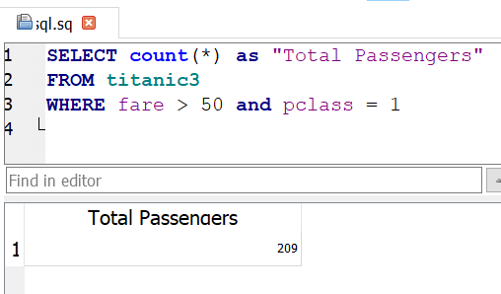

2.

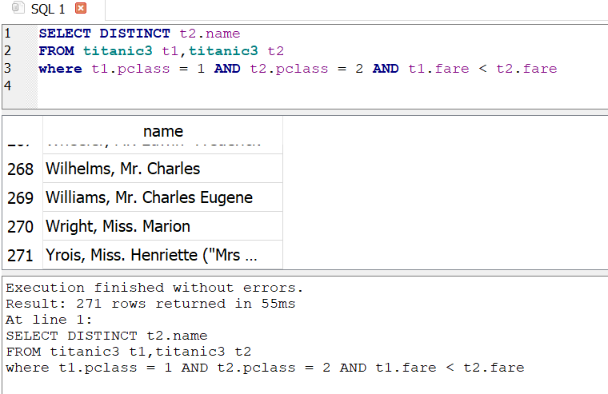

3.

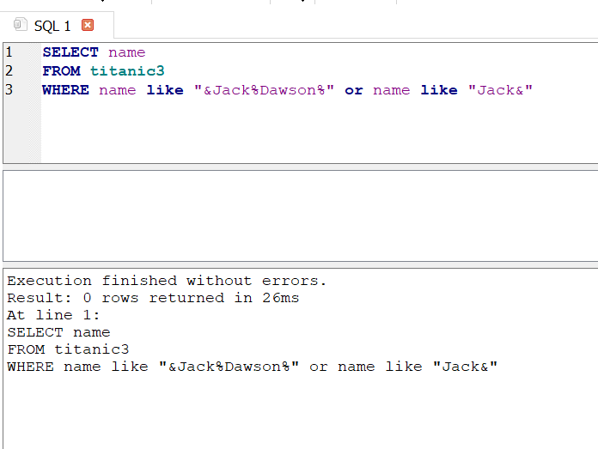

4.

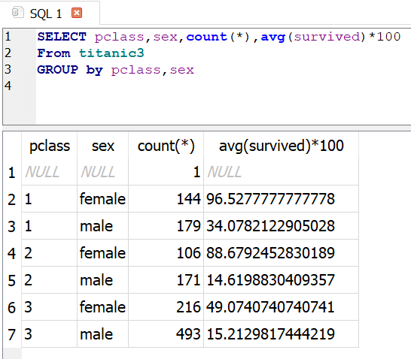

**POKEMONS**

1.

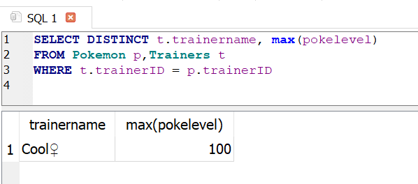

2.

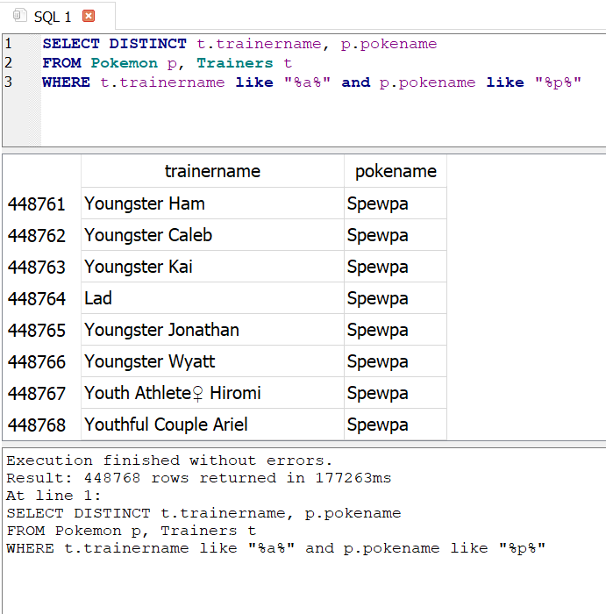

3.

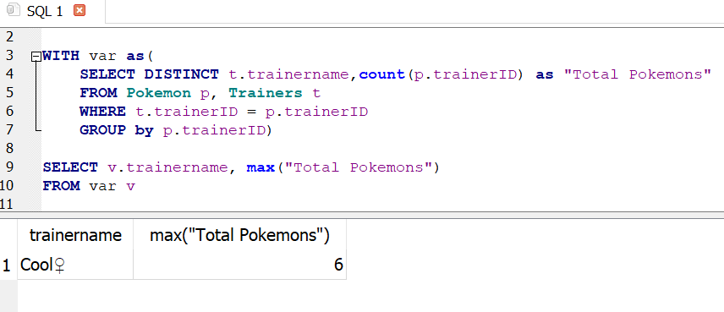

**AIRBNB**

1.

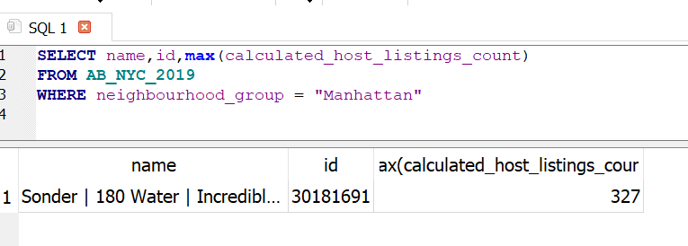

2.

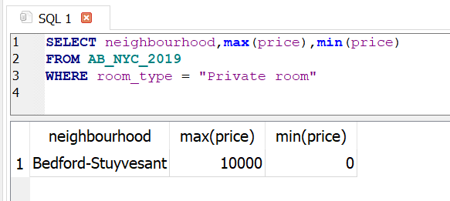

3.

